ASR 2197 EPSON GPC - Picking Statistics by Picker

- Picker Maintenance (new)
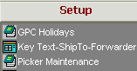

Data to input:
- Picker ID = employee ID,
- Picker Name
- Active – check if picker ID is active and valid

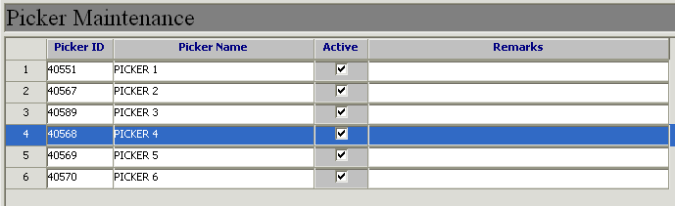

- Pick List
Added barcode Wavekey + Zone
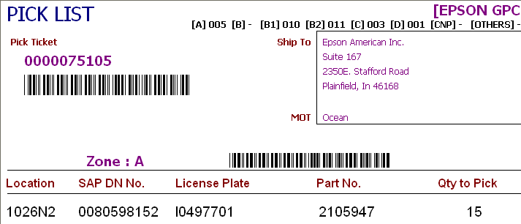
Wave + Zone barcode

- Pick Release (New) - Pick List assignment milestone by Wave and Zone
(Assumption: 1 wave and 1 zone to be assigned to ONLY 1 picker)

HUB:: Outbound - > [02] Pick Release
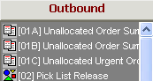

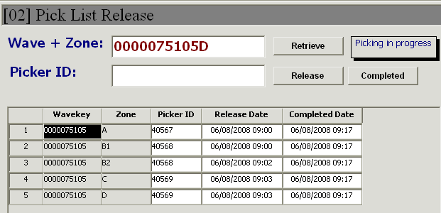

Steps to Release Pick:
  - Scan wave+zone (combined barcode) on pick list
  - Input Picker ID
  - Click button [Release]
  - System will capture current system date time as Pick start

Steps to Complete Pick Step:
  - Scan wave+zone (combined barcode) on pick list
  - Click button [Complete]
  - System will capture current system date time as Pick Completed

- Customer Order Status Report
Added status Picking In Progress and Picked

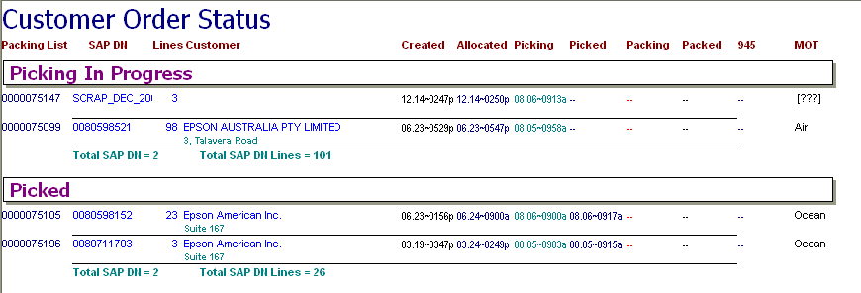

- Report - Picking Statistics by Picker (New) ( date range by pick completion date)

HUB:: Analysis -> Picking Statistic by Picker

